# **Course End Project: Comparison of Region Based on Sales**

## Data Blending

Sample Superstore Dataset is uploaded and data blending is created for the project.

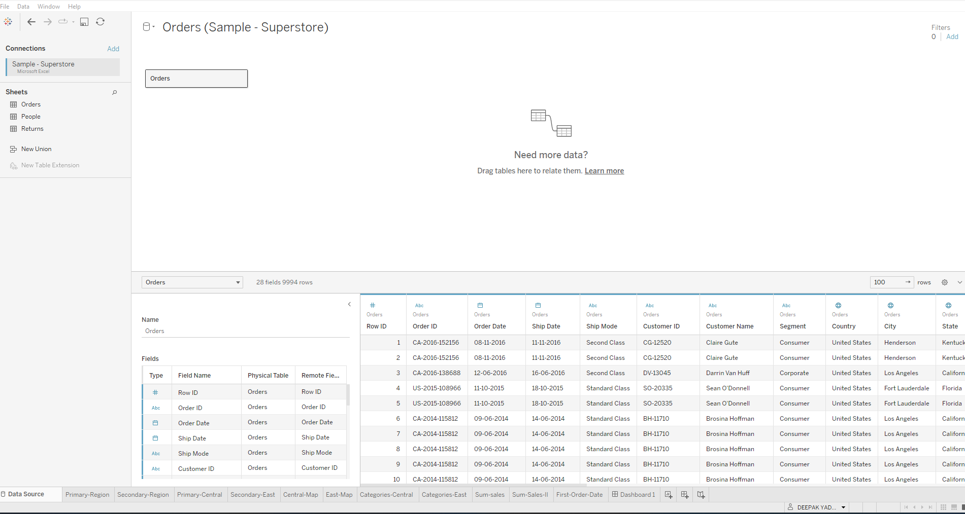

## Hierarchy

A hierarchy called Location is created with Country, State, City, and Postal Code.

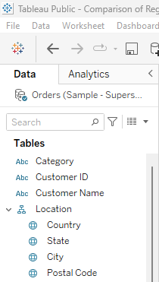

# Primary Region and Secondary Region

Created two parameters, Primary Region and Secondary Region with all sales data.

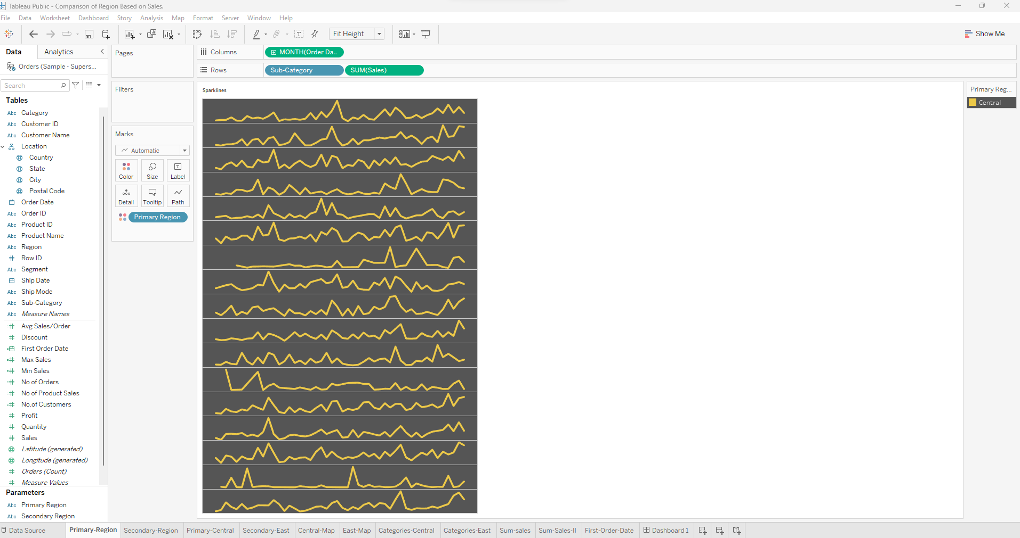

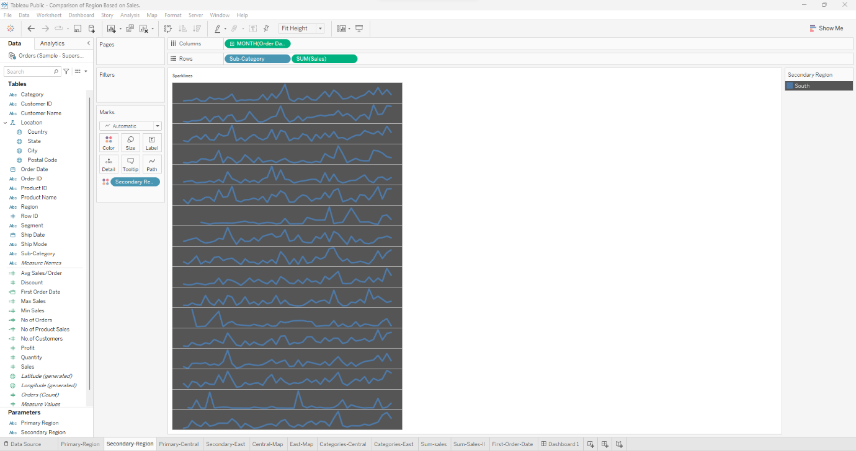

# First Order Date

Created a Calculated Field and named it as the First Order Date.

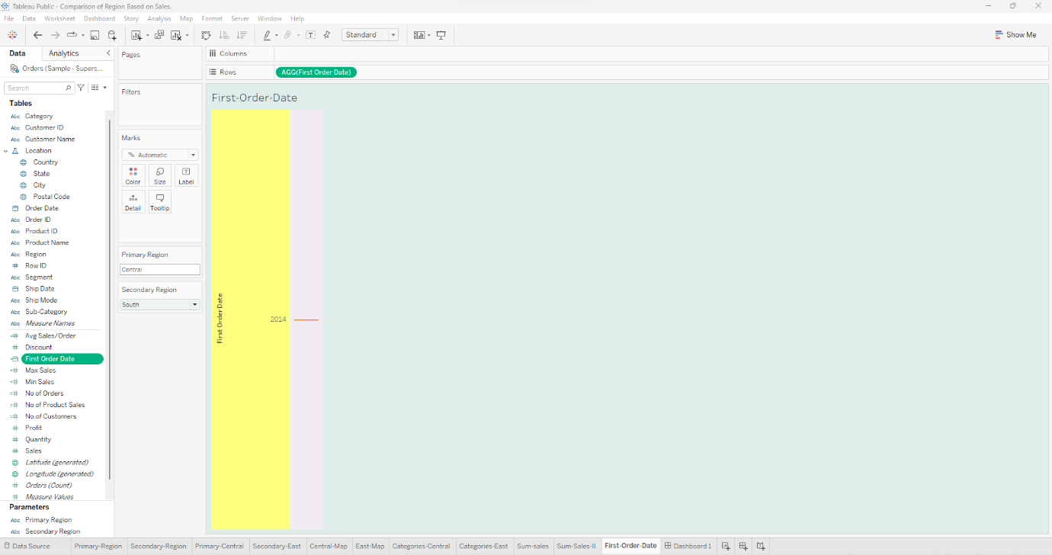

# Dashboard

Created a dashboard below are the points highlighted.

•First Order Date

•Total Sales

•Average Sales per Order

•No. of Customers

•No. of Orders

•No. of Products in Sale

